**Power BI Assignment 4**

1. Make a simple dashboard and show columns, bar charts, line charts, and area charts.

ANS.1:: COLUMN-CHART

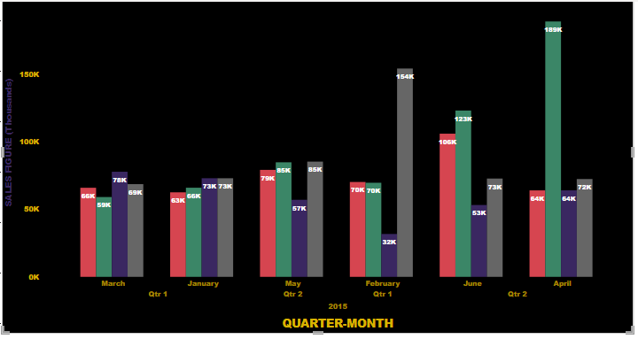

2.AREA -CHART 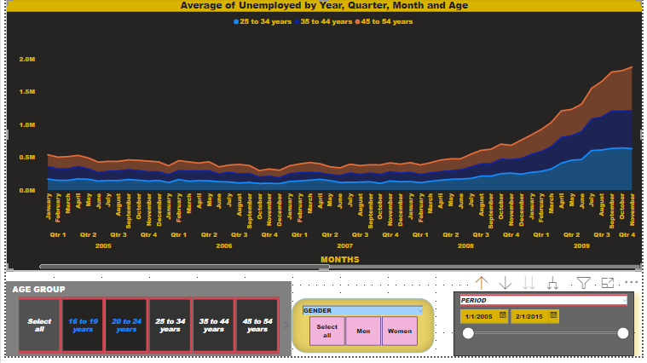

3.LINE CHART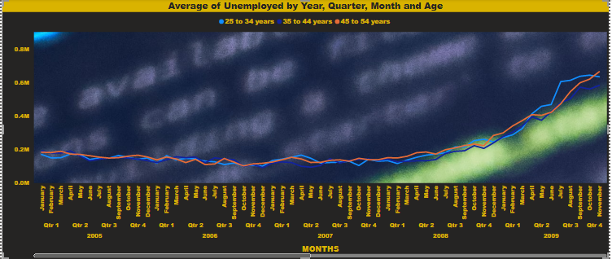

1. Make a simple dashboard and show combination chart, Scatter chart, Shape chart, and Treemap chart.

ANS .. 1..COMBINATION-CHART

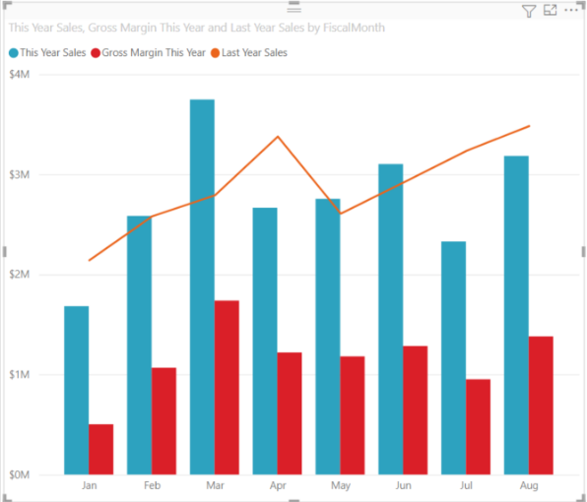

2.SCATTER-CHART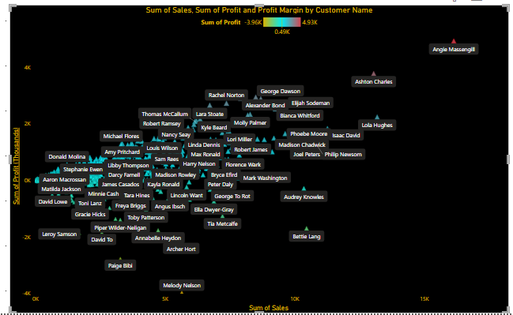

3.TREE-MAP 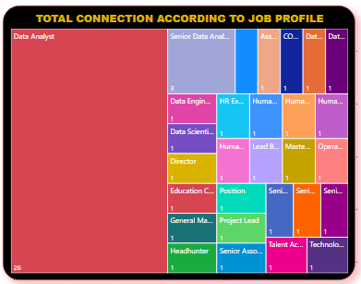

4.SHAPE-CHART

1. Make a dashboard and show 2 maps visualization i.e. basic map and filler maps.

ANS ..BASIC-MAP

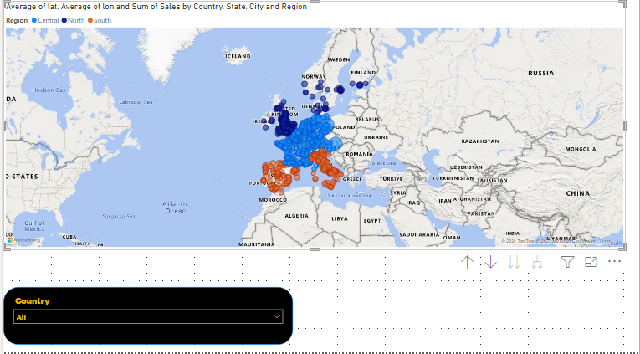

2.FILLED-MAP 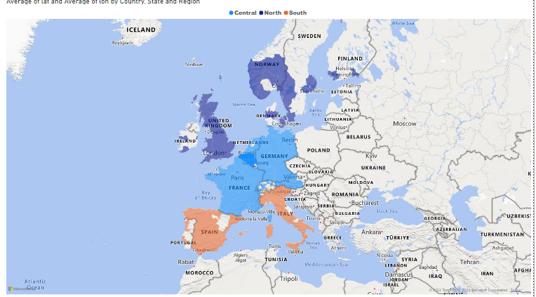

1. Create a report which has:

Bar chart

Card visualizations

Combo chart visualizations

Matrix visualizations

Column chart visualizations

guide: Sales data can be used ANSWER…

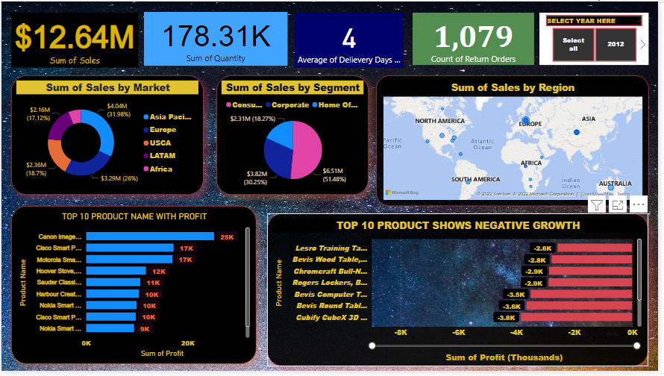

1. Make a report to analyze product sales using treemap visualization.

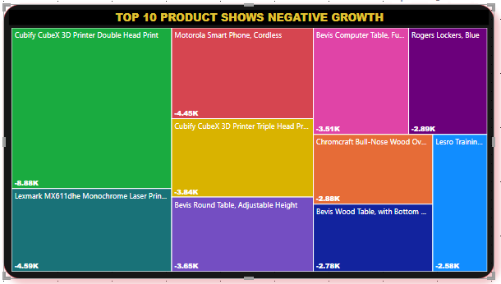

1. Make a dashboard on sales data (Minimum 4 tiles).

